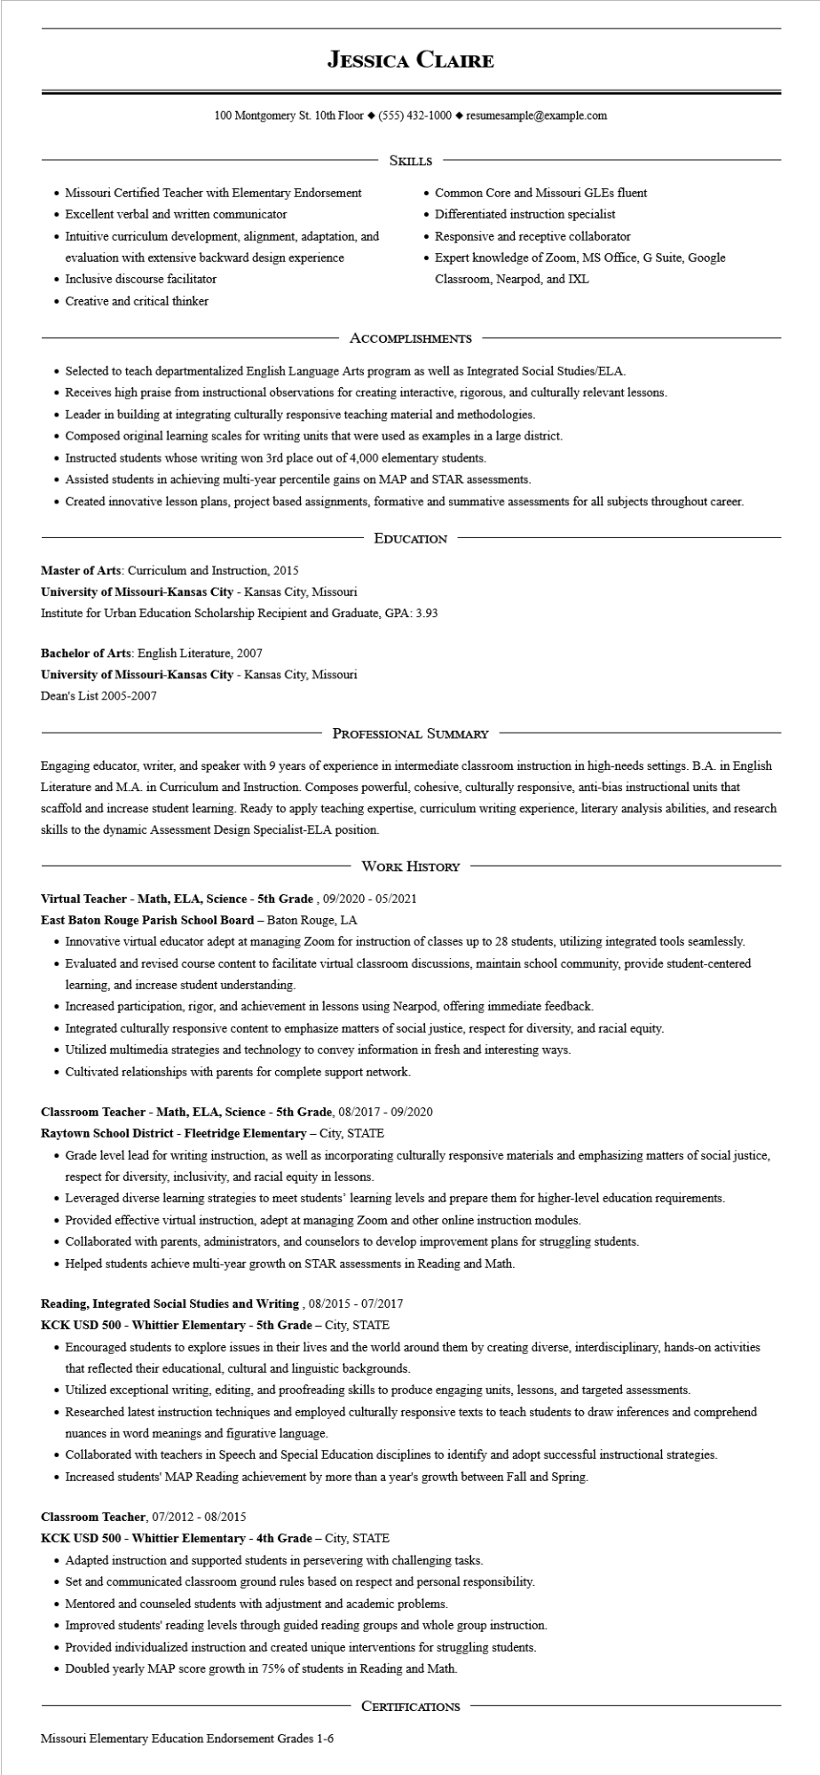
JESSICA CLAIRE
100 Montgomery St. 10th Floor (555) 432-1000◆ resumesample@example.com
• Missouri Certified Teacher with Elementary Endorsement
• Excellent verbal and written communicator
• Intuitive curriculum development, alignment, adaptation, and
evaluation with extensive backward design experience
• Inclusive discourse facilitator
SKILLS
• Common Core and Missouri GLEs fluent
• Differentiated instruction specialist
• Responsive and receptive collaborator
Expert knowledge of Zoom, MS Office, G Suite, Google Classroom, Nearpod, and IXL
• Creative and critical thinker
ACCOMPLISHMENTS
• Selected to teach departmentalized English Language Arts program as well as Integrated Social Studies/ELA.
• Receives high praise from instructional observations for creating interactive, rigorous, and culturally relevant lessons.
• Leader in building at integrating culturally responsive teaching material and methodologies.
• Composed original learning scales for writing units that were used as examples in a large district.
• Instructed students whose writing won 3rd place out of 4,000 elementary students.
• Assisted students in achieving multi-year percentile gains on MAP and STAR assessments.
• Created innovative lesson plans, project based assignments, formative and summative assessments for all subjects throughout career.
EDUCATION
Master of Arts: Curriculum and Instruction, 2015
University of Missouri-Kansas City - Kansas City, Missouri
Institute for Urban Education Scholarship Recipient and Graduate, GPA: 3.93
Bachelor of Arts: English Literature, 2007
University of Missouri-Kansas City - Kansas City, Missouri
Dean's List 2005-2007
PROFESSIONAL SUMMARY
Engaging educator, writer, and speaker with 9 years of experience in intermediate classroom instruction in high-needs settings. B.A. in English Literature and M.A. in Curriculum and Instruction. Composes powerful, cohesive, culturally responsive, anti-bias instructional units that scaffold and increase student learning. Ready to apply teaching expertise, curriculum writing experience, literary analysis abilities, and research skills to the dynamic Assessment Design Specialist-ELA position.
WORK HISTORY
Virtual Teacher - Math, ELA, Science - 5th Grade, 09/2020- 05/2021
East Baton Rouge Parish School Board - Baton Rouge, LA
• Innovative virtual educator adept at managing Zoom for instruction of classes up to 28 students, utilizing integrated tools seamlessly.
• Evaluated and revised course content to facilitate virtual classroom discussions, maintain school community, provide student-centered learning, and increase student understanding.
• Increased participation, rigor, and achievement in lessons using Nearpod, offering immediate feedback.
• Integrated culturally responsive content to emphasize matters of social justice, respect for diversity, and racial equity.
• Utilized multimedia strategies and technology to convey information in fresh and interesting ways.
• Cultivated relationships with parents for complete support network.
Classroom Teacher - Math, ELA, Science - 5th Grade, 08/2017 - 09/2020
Raytown School District - Fleetridge Elementary - City, STATE
• Grade level lead for writing instruction, as well as incorporating culturally responsive materials and emphasizing matters of social justice, respect for diversity, inclusivity, and racial equity in lessons.
• Leveraged diverse learning strategies to meet students' learning levels and prepare them for higher-level education requirements.
• Provided effective virtual instruction, adept at managing Zoom and other online instruction modules.
• Collaborated with parents, administrators, and counselors to develop improvement plans for struggling students.
• Helped students achieve multi-year growth on STAR assessments in Reading and Math.
Reading, Integrated Social Studies and Writing, 08/2015 - 07/2017
KCK USD 500 - Whittier Elementary - 5th Grade - City, STATE
• Encouraged students to explore issues in their lives and the world around them by creating diverse, interdisciplinary, hands-on activities that reflected their educational, cultural and linguistic backgrounds.
• Utilized exceptional writing, editing, and proofreading skills to produce engaging units, lessons, and targeted assessments.
• Researched latest instruction techniques and employed culturally responsive texts to teach students to draw inferences and comprehend nuances in word meanings and figurative language.
• Collaborated with teachers in Speech and Special Education disciplines to identify and adopt successful instructional strategies.
• Increased students' MAP Reading achievement by more than a year's growth between Fall and Spring.
Classroom Teacher, 07/2012 - 08/2015
KCK USD 500 - Whittier Elementary - 4th Grade - City, STATE
• Adapted instruction and supported students in persevering with challenging tasks.
• Set and communicated classroom ground rules based on respect and personal responsibility.
• Mentored and counseled students with adjustment and academic problems.
• Improved students' reading levels through guided reading groups and whole group instruction.
• Provided individualized instruction and created unique interventions for struggling students.
• Doubled yearly MAP score growth in 75% of students in Reading and Math.
Missouri Elementary Education Endorsement Grades 1-6
CERTIFICATIONS

